|  |
| --- |
| **A Project Based Seminar Report**  **on**  **‘Study of Different Deep Learning Models used in stock price prediction’**   Submitted to theSavitribai Phule Pune UniversityIn partial fulfillment for the award of the Degree ofBachelor of EngineeringinInformation TechnologybyHarshali Bedmutha(T150028508)T.E. (Information Technology)Under the guidance of **Dr. Mrs. Himangi Pande** **MIT_Logo**  **DEPARTMENT OF INFORMATION TECHNOLOGY**  **MAHARASHTRA INSTITUTE OF TECHNOLOGY**  **PUNE-411038**  **Academic Year 2017-2018**  **Semester II**  Affiliated to  uop_logo  Savitribai Phule Pune University |
| MIT_Logo  **MAEER’S**  **MAHARASHTRA INSTITUTE OF TECHNOLOGY, PUNE** DEPARTMENT OF INFORMATION TECHNOLOGY**CERTIFICATE** This is to certify that the project based seminar report entitled **“Comparative study of RNN,LSTM and CNN in stock market prediction”** being submitted by **Harshali Bedmutha (T150028508)** is a record of bonafide work carried out by him/her under the supervision and guidance of Dr. Mrs. Himangi Pande in partial fulfillment of the requirement for **TE (Information Technology Engineering) a 2015 course** of Savitribai Phule Pune University, Pune in the academic year 2017- 2018.  Date: 15/03/2018  Place: Pune Dr. Sumedha Sirsikar **Mrs. Himangi Pande Head of the Department, IT**  Dr. L. K. Kshirsagar  Principal  \_\_\_\_\_\_\_\_\_\_\_\_\_\_\_\_\_\_\_\_\_\_\_\_\_\_\_\_\_\_\_\_\_\_\_\_\_\_\_\_\_\_\_\_\_\_\_\_\_\_\_\_\_\_\_\_\_\_\_\_\_\_\_\_\_\_\_\_\_\_\_\_\_\_\_\_\_\_    This Project Based Seminar report has been examined by us as per the Savitribai Phule Pune University, Pune requirements at Maharashtra Institute of Technology, Pune aˆ 411038 on . . . . . . . . . . .  Internal Examiner External Examiner | | |

###### *ACKNOWLEDGEMENT*

I take this opportunity to express my sincere appreciation for the cooperation given by

Prof. Mrs. Sumedha Sirsikar, HOD (Department of Information Technology) and

need a special mention for all the motivation and support

I take this opportunity to express my sincere appreciation for the cooperation

given by my guide Dr. Mrs. Himangi Pande (Department of Information Technology) and need a special mention for all the motivation and support. I am deeply indebted to my guide for completion of this seminar for which she has guided and helped me going out of the way.

For all eﬀorts behind the Seminar report, I would also like to express my sincere appreciation to staﬀ of Department of Information Technology, Maharashtra Institute of Technology Pune, for their extended help and suggestions at every stage.

I would also like to thank all my friends who have helped me to understand the concepts related to the seminar.

Lastly I would like to thank my parents and family for being a constant support and motivation for me.

**Harshali Bedmutha**

Roll No: 306006

T.E. (Information Technology)

MIT, Pune 41103

## Abstract

*A stock market, equity market or share market is the aggregation of buyers and sellers of stocks (also called shares), which represent ownership claims on businesses; these may include securities listed on a public stock exchange as well as those only traded privately.*

*Stock market or equity market have a profound impact in today’s economy. In today’s world stock market has always been in trend. A rise or fall in the share price has an important role in determining the investor’s gain. Stock market prediction is the act of trying to determine the future value of a company stock or other financial instrument traded on an exchange. Predictions on stock market prices are a great challenge due to the fact that it is an immensely complex, chaotic and dynamic environment. There are many studies from various areas aiming to take on that challenge and Machine Learning approaches have been the focus of many of them. There are many examples of Machine Learning algorithms been able to reach satisfactory results when doing that type of prediction. Different Deep Learning algorithms for prediction of stock market data include Recurrent Neural Network (RNN), Long Short Term Memory (LSTM), Convolutional Neural Network (CNN) and many more. The successful prediction of a stock's future price could yield significant profit. The seminar provides description about the above mentioned techniques.*

**Keywords:** *Stock market, Stock market prediction, Machine Learning, RNN, CNN, LSTM*

## INDEX

|  |  |  |  |  |
| --- | --- | --- | --- | --- |
| **Topic** | | | | **Page No.** |
|  |  |  | |  |
| 1. | INTRODUCTION TO STOCK MARKET | | |  |
|  | 1.1 | OVERVIEW OF STOCK MARKET PREDICTION | |  |
|  | 1.2 | MOTIVATION | |  |
|  | 1.3 | AIM AND OBJECTIVES | |  |
|  | 1.4 | INTRODUCTION TO DEEP LEARNING | |  |
|  | 1.5 | INTRODUCTION TO SEMINAR TOPIC | |  |
|  |  | | |  |
| 2. | LITERATURE SURVEY | | |  |
|  |  | | |  |
| 3. | INTRODUCTION TO RNN, CNN AND LSTM | | |  |
|  | 3.1 | INTRODUCTION TO RNN | |  |
|  |  | 3.1.1 | LONG TERM DEPENDNECY |  |
|  | 3.2 | INTRODUCTION TO LSTM | |  |
|  | 3.3 | INTRODUCTION TO CNN | |  |
|  |  | | |  |
| 4 | COMPARATIVE STUDY OF RNN, CNN AND LSTM IN STOCK PRICE PREDICTION | | |  |
|  | 4.1 | METHODOLOGY | |  |
|  | 4.2 | RESULTS | |  |
|  |  | | |  |
| 5 | CONCLUSION | | |  |
|  |  | | |  |
|  | BIBLIOGRAPHY | | |  |

**LIST OF FIGURES**

|  |  |  |
| --- | --- | --- |
|  | **Title** | **Page no.** |
| 1.1 | Stock markets |  |
| 1.2 | Stock markets |  |
| 3.1 | Recurrent Neural Network(RNN) Loop |  |
| 3.2 | Unfolding Loop of RNN |  |
| 3.3 | Long Term Dependency |  |
| 3.4 | Repeating Module of RNN |  |
| 3.5 | Repeating Module of Long Short Term Dependency(LSTM) |  |
| 3.6 | LSTM- Forget Gate Layer |  |
| 3.7 | LSTM- Tanh Layer |  |
| 3.8 | LSTM-Multiplying Layer |  |
| 3.9 | LSTM-Output Layer |  |
| 3.10 | Convolution Layer |  |
| 3.11 | Pooling Layer |  |
| 4.1 | Block diagram of Proposed method |  |
|  |  |  |

**LIST OF TABLES**

|  |  |  |
| --- | --- | --- |
|  | **Title** | **Page no.** |
| I | Error Percentage |  |

**LIST OF ABBREVIATIONS**

|  |  |  |
| --- | --- | --- |
|  | **Abbreviation** | **Full-text** |
| 1 | RNN | Recurrent Neural Network |
| 2 | CNN | Convolutional Neural Network |
| 3 | LSTM | Long Short Term Memory |
| 4 | ETF | Exchange Trade Fund |
| 5 | NSE | National Stock Exchange |

## 

**CHAPTER 1**

**INTRODUCTION TO STOCK MARKET**

A stock market, equity market or share market is the aggregation of buyers and sellers (a loose network of economic transactions, not a physical facility or discrete entity) of stocks (also called shares), which represent ownership claims on businesses; these may include securities listed on a public stock exchange as well as those only traded privately. Examples of the latter include shares of private companies which are sold to investors through equity crowd funding platforms. Stock exchanges list shares of common equity as well as other security types, e.g. corporate bonds and convertible bonds.

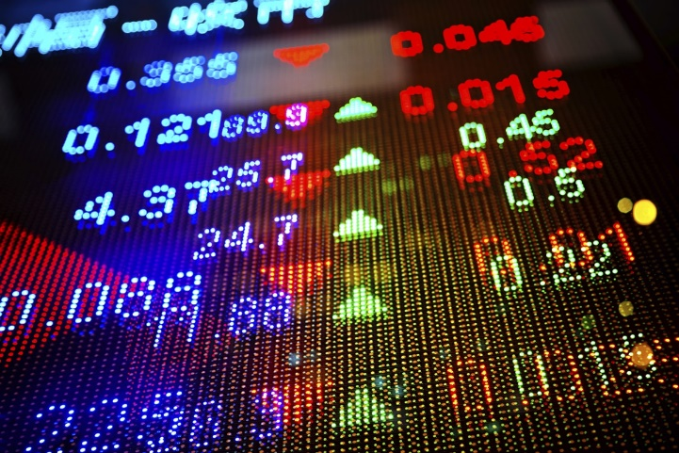 [7] [8]

**Fig 1.1 Fig 1.2**

A stock exchange is an exchange where stock brokers and traders can buy and sell shares of stock, bonds, and other securities. Many large companies have their stocks listed on a stock exchange. This makes the stock more liquid and thus more attractive to many investors. The exchange may also act as a guarantor of settlement. Other stocks may be traded "over the counter", that is, through a dealer. Some large companies will have their stock listed on more than one exchange in different countries, so as to attract international investors.

As of 2015, there are a total of 60 stock exchanges in the world with a total market capitalization of $69 trillion. Of these, there are 16 exchanges with a market capitalization of $1 trillion or more, and they account for 87% of global market capitalization. Apart from the Australian Securities Exchange, these 16 exchanges are based in one of three continents: North America, Europe and Asia.

* 1. **Overview of Stock Market Prediction**

Stock market prediction is the act of trying to determine the future value of a company stock or other financial instrument traded on an exchange. The successful prediction of a stock's future price could yield significant profit. The efficient-market hypothesis suggests that stock prices reflect all currently available information and any price changes that are not based on newly revealed information thus are inherently unpredictable. Others disagree and those with this viewpoint possess myriad methods and technologies which purportedly allow them to gain future price information.

Prediction methodologies fall into two broad categories which can (and often do) overlap. They are fundamental analysis and technical analysis.

### Fundamental analysis

Fundamental Analysts are concerned with the company that underlies the stock itself. They evaluate a company's past performance as well as the credibility of its accounts. Many performance ratios are created that aid the fundamental analyst with assessing the validity of a stock, such as the P/E ratio. Warren Buffett is perhaps the most famous of all Fundamental Analysts.

### Technical analysis

Technical analysts or chartists are not concerned with any of the company's fundamentals. They seek to determine the future price of a stock based solely on the

(potential) trends of the past price (a form of time series analysis). Numerous patterns are employed such as the head and shoulders or cup and saucer. Alongside the patterns, techniques are used such as the exponential moving average (EMA). Candle stick patterns, believed to have been first developed by Japanese rice merchants, are nowadays widely used by technical analysts.

* 1. **Motivation behind project topic**

Stock price prediction is a classic and important problem. With a successful model for stock prediction, we can gain insight about market behavior over time, spotting trends that would otherwise not have been noticed. With the increasingly computational power of the computer, machine learning will be an eﬃcient method to solve this problem. We can try to improve the accuracy of prediction by modifying the existing algorithms.

* 1. **Aim and Objectives of the work**

The aim of this project is to create a prediction system for stock market and accurately predict the future value of stock based on the past data.

Objectives:

* To develop a efficient system for stock prediction for users
* To determine various ways in which the analysis of stock market can be done (eg: technical analysis or sentiment analysis)
* To innovate the existing system by adding newer features like gamification

to make it more user friendly

**1.4 Introduction to Deep Learning**

Deep learning (also known as deep structured learning or hierarchical learning) is part of a broader family of machine learning methods based on learning data representations, as opposed to task-specific algorithms. Learning can be supervised, semi-supervised or unsupervised. Deep learning models are loosely related to information processing and communication patterns in a biological nervous system, such as neural coding that attempts to define a relationship between various stimuli and associated neuronal responses in the brain. Deep learning architectures such as deep neural networks, deep belief networks and recurrent neural networks have been applied to fields including computer vision, speech recognition, natural language processing, audio recognition, social network filtering, machine translation, bioinformatics and drug design, where they have produced results comparable to and in some cases superior to human experts.

* 1. **Introduction to Seminar Topic**

The seminar aims at studying different Deep Learning algorithms used for Stock Market Price Prediction. The main focus is to study Recurrent Neural Network, Long Short Term Memory and Convolutional Neural Networks. Recurrent Neural Networks (RNN) are a class of artificial neural network which became more popular in the recent years. The RNN is a special network, which has unlike feedforward networks recurrent connections. One major drawback of RNNs is that the range of contextual information is limited and the Back-Propagation through time does not work properly. The LSTM is designed to overcome the error back flow problems through carousels in their special units. This is all done with still a low computational complexity of O(1) and additionaly the LSTM impoves the RNN with the ability to bridge time intervals. A CNN will learn to recognize patterns across space. So, as you say, a CNN will learn to recognize

components of an image (e.g., lines, curves, etc.) and then learn to combine these components to recognize larger structures (e.g., faces, objects, etc.).

**CHAPTER 2**

**LITERATURE SURVEY**

When it comes to stock markets, in addition to its inherent complexity and dynamism, there has been a constant debate on the predictability of stock returns. Stock market or equity market have a profound impact in today’s economy. A rise or fall in the share price has an important role in determining the investor’s gain. Many existing forecasting methods make use of both linear and non-linear algorithms but they focus on predicting the stock index movement or price forecasting for a single company using the daily closing price. In [1] the proposed method is a model independent approach. They are not ﬁtting the data to a speciﬁc model, rather they are identifying the latent dynamics existing in the data using deep learning architectures. In this work they use three different deep learning architectures for the price prediction of NSE listed companies and compares their performance. [1] uses a sliding window approach for predicting future values on a short term basis. The performance of the models were quantiﬁed using percentage error. There are at least four types of stock data: (a) the historic price data of the stock (e.g. volume, high, low, open); (b) the technical analysis data that is calculated from (a) (e.g. moving average convergence / divergence (MACD)); (c) the historic price data of market indexes and/or other related stocks; (d) the economic fundamentals (e.g. gross domestic product (GDP), oil price). [1] uses time series data or historic price data for analysis. While [2] used the (a) and (c) but not (b) type of stock data, in an effort to avoid the co-founding pitfalls, with also a limit of not including the (d) type of data.

In [2] the presented paper modeled and predicted China stock returns using LSTM. The historical data of China stock market were transformed into 30-days-long sequences with 10 learning features and 3-day earning rate labeling. The model was fitted by training on 900000 sequences and tested using the other 311361 sequences.

[3] studies the usage of LSTM networks on that scenario, to predict future trends of stock prices based on the price history, alongside with technical analysis indicators. In [3] a prediction model was built, and a series of experiments were executed and theirs results analyzed against a number of metrics to assess if this type of algorithm presents and improvements when compared to other Machine Learning methods and investment strategies. The results that were obtained were promising, getting up to an average of 55.9% of accuracy when predicting if the price of a particular stock is going to go up or not in the near future. In [4] Convolutional Neural Networks are used. To avoid the high volatility of the market and to maximize the proﬁt, ETFs(Exchange Traded Funds) are used as primary ﬁnancial assets in [4]. Adopting a sliding window approach, [4] generate our images by taking snapshots that are bounded by the window over a daily period. [4] performs daily predictions, namely, regression for predicting the ETF prices and classiﬁcation for predicting the movement of the prices on the next day, which can be modiﬁed to estimate weekly or monthly trends. To increase the number of images,[4] uses numerous ETFs. In [4] instead of using only the price values, it extracts some of the most commonly used fundamental analysis indicators and included them to the feature set. These indicators help the model to grasp the underlying dynamics of the market more easily.

**CHAPTER 3**

**INTRODUCTION TO RNN, CNN AND LSTM**

**3.1 Recurrent Neural Network (RNN)**

Humans don’t start their thinking from scratch every second. As you read this essay, you understand each word based on your understanding of previous words. You don’t throw everything away and start thinking from scratch again. Your thoughts have persistence. Traditional neural networks can’t do this, and it seems like a major shortcoming. Recurrent neural networks address this issue. They are networks with loops in them, allowing information to persist. **Recurrent Neural Networks have loops**

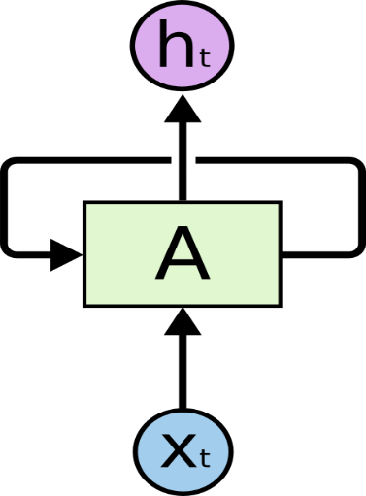[5]

**Fig 3.1**

In the above diagram, a chunk of neural network, *A,* looks at some input *xt* and outputs a value *ht*. A loop allows information to be passed from one step of the network to the next. These loops make recurrent neural networks seem kind of mysterious. However, if you think a bit more, it turns out that they aren’t all that different than a normal neural network. A recurrent neural network can be thought of as multiple copies of the same network, each passing a message to a successor. Consider what happens if we unroll the loop

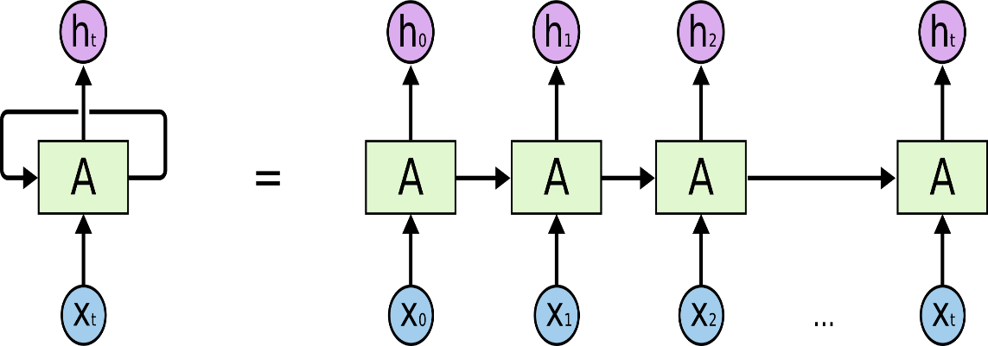[5]

**Fig 3.2**

**An unrolled recurrent neural network.**

This chain-like nature reveals that recurrent neural networks are intimately related to sequences and lists. They’re the natural architecture of neural network to use for such data. And they certainly are used. In the last few years, there have been incredible success applying RNNs to a variety of problems: speech recognition, language modeling, translation, image captioning and much more.

**3.1.1 Long Term Dependency**

Sometimes, we only need to look at recent information to perform the present task. For example, consider a language model trying to predict the next word based on the previous ones. If we are trying to predict the last word in “the clouds are in the sky,” we don’t need any further context – it’s pretty obvious the next word is going to be sky. In such cases, where the gap between the relevant information and the place that it’s needed is small, RNNs can learn to use the past information.

But there are also cases where we need more context. Consider trying to predict the last word in the text “I grew up in France… I speak fluent French.” Recent information suggests that the next word is probably the name of a language, but if we want to narrow down which language, we need the context of France, from further back. It’s entirely

possible for the gap between the relevant information and the point where it is needed to become very large.

Unfortunately, as that gap grows, RNNs become unable to learn to connect the information.

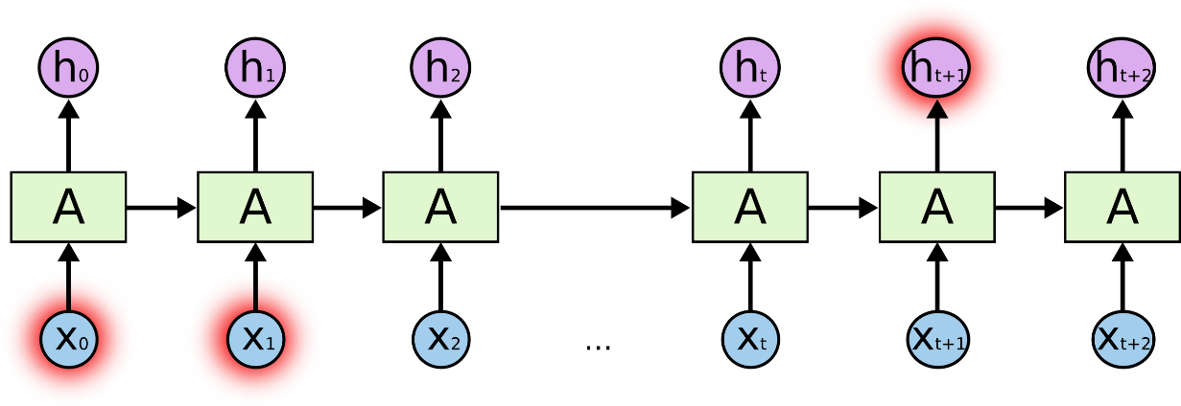[5]

**Fig 3.3**

* 1. **Long Short Term Memory(LSTM)**

Long Short Term Memory networks – usually just called “LSTMs” – are a special kind of RNN, capable of learning long-term dependencies. They were introduced by Hochreiter & Schmidhuber (1997), and were refined and popularized by many people in following work.[1](file:///C:\Users\devesh\Desktop\ref\RNN%20AND%20LSTM.html#fn1) They work tremendously well on a large variety of problems, and are now widely used.

LSTMs are explicitly designed to avoid the long-term dependency problem. Remembering information for long periods of time is practically their default behavior, not something they struggle to learn!

All recurrent neural networks have the form of a chain of repeating modules of neural network. In standard RNNs, this repeating module will have a very simple structure, such as single tanh layer.

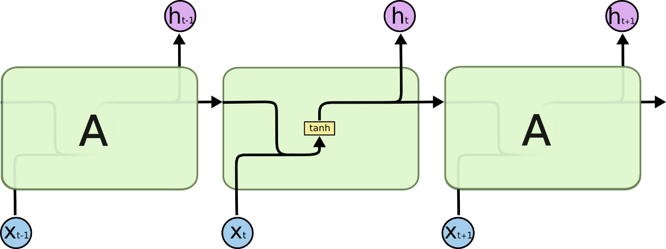[5]

**Fig 3.4**

**The repeating module in a standard RNN contains a single layer.**

LSTMs also have this chain like structure, but the repeating module has a different structure. Instead of having a single neural network layer, there are four, interacting in a very special way.

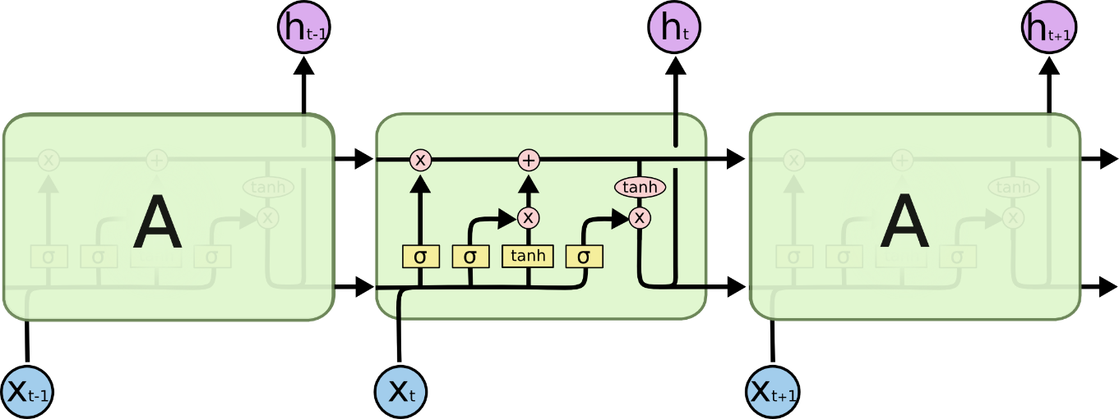[5]

**Fig 3.5**

The first step in our LSTM is to decide what information we’re going to throw away from the cell state. This decision is made by a sigmoid layer called the “forget gate layer.” It looks at *ht*−1 and *xt*, and outputs a number between 0 and 1 for each number in the cell state *Ct*−1. A 1 represents “completely keep this” while a 0 represents “completely get rid of this.”

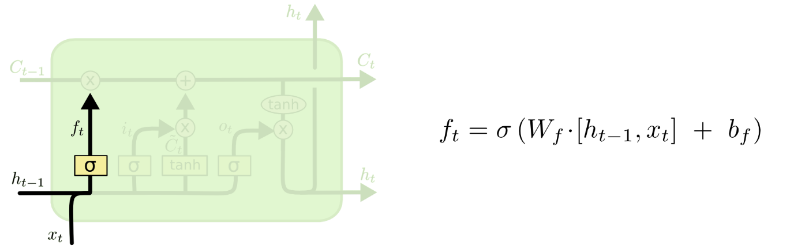[5]

**Fig 3.6**

The next step is to decide what new information we’re going to store in the cell state. This has two parts. First, a sigmoid layer called the “input gate layer” decides which values we’ll update. Next, a tanh layer creates a vector of new candidate values, *C*~, that could be added to the state. In the next step, we’ll combine these two to create an update to the state.

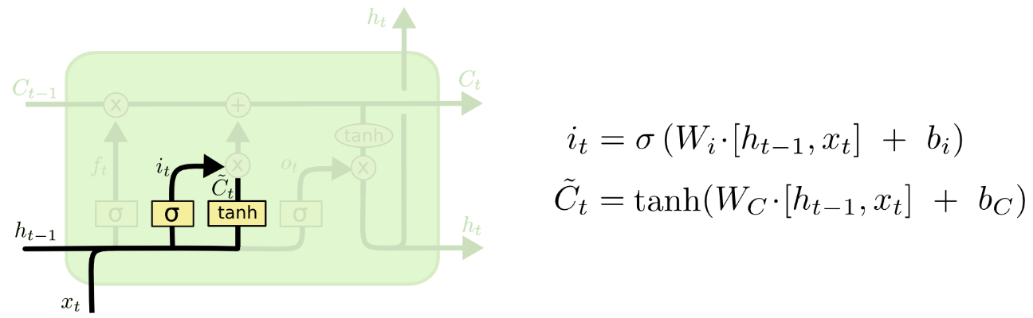[5]

**Fig 3.7**

It’s now time to update the old cell state, *Ct*−1, into the new cell state *Ct*. The previous steps already decided what to do, we just need to actually do it.We multiply the old state by *ft*, forgetting the things we decided to forget earlier. Then we add *it*∗*C*~*t*. This is the new candidate values, scaled by how much we decided to update each state value.

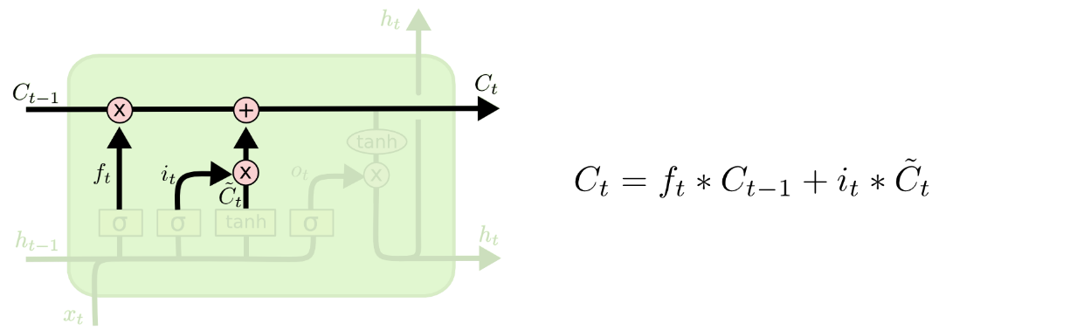[5]

**Fig 3.8**

Finally, we need to decide what we’re going to output. This output will be based on our cell state, but will be a filtered version. First, we run a sigmoid layer which decides what parts of the cell state we’re going to output. Then, we put the cell state through tanh(to push the values to be between −1 and 1) and multiply it by the output of the sigmoid gate, so that we only output the parts we decided to.

For the language model example, since it just saw a subject, it might want to output information relevant to a verb, in case that’s what is coming next. For example, it might output whether the subject is singular or plural, so that we know what form a verb should be conjugated into if that’s what follows next.

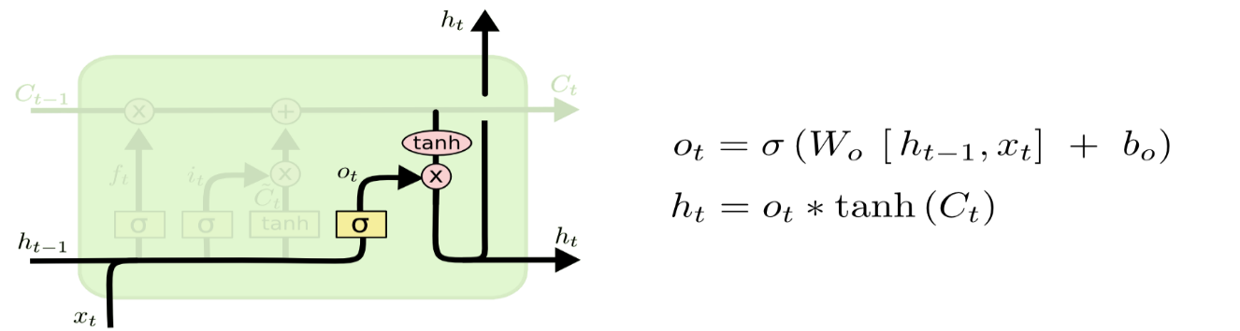[5]

**Fig 3.9**

* 1. **Convolutional Neural Network(CNN)**

Convolutional Neural Networks are very similar to ordinary Neural Networks. ConvNet architectures make the explicit assumption that the inputs are images, which allows us to encode certain properties into the architecture. These then make the forward function more efficient to implement and vastly reduce the amount of parameters in the network. The first thing to know about convolutional networks is that they don’t perceive images like humans do. Therefore, you are going to have to think in a different way about what an image means as it is fed to and processed by a convolutional network.

Convolutional networks perceive images as volumes; i.e. three-dimensional objects, rather than flat canvases to be measured only by width and height. That’s because digital color images have a red-blue-green (RGB) encoding, mixing those three colors to produce the color spectrum humans perceive. A convolutional network ingests such images as three separate strata of color stacked one on top of the other.

So a convolutional network receives a normal color image as a rectangular box whose width and height are measured by the number of pixels along those dimensions, and whose depth is three layers deep, one for each letter in RGB. Those depth layers are referred to as channels. You will need to pay close attention to the precise measures of

each dimension of the image volume, because they are the foundation of the linear algebra operations used to process images.

Now, for each pixel of an image, the intensity of R, G and B will be expressed by a number, and that number will be an element in one of the three, stacked two-dimensional matrices, which together form the image volume.

Those numbers are the initial, raw, sensory features being fed into the convolutional network, and the ConvNets purpose is to find which of those numbers are significant signals that actually help it classify images more accurately. Rather than focus on one pixel at a time, a convolutional net takes in square patches of pixels and passes them through a filter. That filter is also a square matrix smaller than the image itself, and equal in size to the patch. It is also called a kernel, which will ring a bell for those familiar with support-vector machines, and the job of the filter is to find patterns in the pixels. Following are the layers involved in CNN:

Step 1: The convolution Layer [5]

**Fig 3.10**

Step 2: Pooling Layer

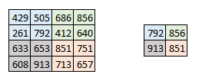[5]

**Fig: 3.11**

Step 3: The output layer

**CHAPTER 4**

**COMPARATIVE STUDY OF RNN, CNN AND LSTM IN STOCK**

**PRICE PREDICTION**

This section describes the technique used in [1] for prediction of stock price. The proposed method is a model independent approach. Here they are not ﬁtting the data to a speciﬁc model, rather we are identifying the latent dynamics existing in

the data using deep learning architectures. In this work they use three different deep learning architectures for the price prediction of NSE listed companies and compares their performance. It applies a sliding window approach for predicting future values on a short term basis. The performance of the models were quantiﬁed using percentage error.

**4.1 METHODOLOGY**

**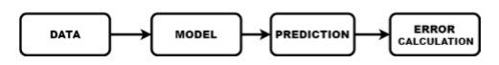**[6]

**Fig 4.1**

The data set consists of minute wise stock price for 1721 NSE listed companies for the period of July 2014 to June 2015. It includes information like day stamp, time stamp, transaction id, stock price and volume of stock sold in each minute. For this work they have selected two different sectors, IT sector and Pharma sector. Two companies from IT sector and one company from Pharma sector were taken for the study. These companies were identiﬁed by the help of NIFTYIT index and NIFTY-Pharma index. The data for these three companies were extracted from the available data and was subjected to preprocessing to obtain the stock price. The work is based on a sliding window approach for a short term future prediction. The window size was ﬁxed to be 100 minutes with an overlap of 90 minute’s information and prediction was made for 10 minutes in future. The best window length was identiﬁed by calculating the error for various window sizes. The train data consists of stock price of Infosys for the period July-01-2014 to October-14-2014 and test data consists of stock price for Infosys, TCS and CIPLA for the period of October-16-2014 to November-28-2014. The data varies with in a range of 2000 to 4000 for Infosys and TCS and for Cipla it is 400 to 700. To unify the data range, it was subjected to normalization and was mapped to a range of 0 to 1. This normalized data was given to the network for training. All the models were trained for 1000 epochs by varying the layer size for ﬁne tuning. If the loss (mean squared error) for the current epoch is less than the value obtained in previous epoch, the weight matrices for that epoch is stored. After the training process each of these models were tested and the model with least RMSE (Root Mean Squared Error) is taken

as the ﬁnal model for prediction. They have used three different deep learning architectures, RNN, LSTM and CNN for this work. The error percentage was calculated using :

ep = abs[ Xi(real) −Xi(predicted) ] \* 100

Xi(real)

Where, ep is the error percentage, Xireal is the ith real value and Xipredicted is the ith predicted value. Error percentage gives the magnitude of error present in the output.

**4.2 RESULTS**

**Table I : ERROR PERCENTAGE**

|  |  |  |  |
| --- | --- | --- | --- |
| Company | RNN | LSTM | CNN |
| INFOSYS | 3.90 | 4.18 | 2.36 |
| TCS | 7.65 | 7.82 | 8.96 |
| CIPLA | 3.83 | 3.94 | 3.63 |

From the table it is clear that CNN is giving more accurate results than the other two models.

For proposed methodology CNN is the most efficient algorithm for time series analysis of stock data. This is due to the reason that CNN does not depend on any previous information for prediction. It uses only the current window for prediction.

Even though the other two models are used in many other time dependent data analysis, it is not outperforming the CNN architecture in this case. This is due to sudden changes in stock market that CNN outperforms the rest of the algorithms.

**CHAPTER 5**

**A DEEP LEARNING BASED STOCK TRADING MODEL WITH 2-D CNN TREND DETECTION**

**CHAPTER 6**

**CONCLUSION**

Stock market is one of the topic in trend today. There is a huge amount of buying and selling of stocks on a regular basis. Thus accurate prediction of future price of a stock might be very useful to the investors. Results have also shown that many of the stock trade in countries like US are done through algorithmic analysis on the past data. There are many researches going in the field of stock market prediction. Many systems have been developed for prediction of stock price.

Deep Learning algorithms are extensively used for this purpose. Various methods like RNN, CNN and LSTM are continuously being researched on to apply in stock price prediction. A comparative study of the three above mentioned methods revealed that CNN is the best amongst all. CNN outperforms other algorithms because it uses information from particular instant. Along with the above mentioned techniques stock price prediction can also be done with the help of sentiment analysis. Thus the system can be made more accurate by combining result from technical as well as sentiment analysis.

**BIBLIOGRAPHY**

[1] Sreelekshmy Selvin, Vinayakumar R, Gopalakrishnan E.A, Vijay Krishna Menon, ‘STOCK PRICE PREDICTION USING LSTM,RNN AND CNN-SLIDING WINDOW MODEL’, International Conference on Advances in Computing, Communications and Informatics (ICACCI),IEEE, Udupi, India, Sept 2017

[2] Kai Chen ,Yi Jhou, Fangyan Dai , ‘A LSTM-based method for stock returns prediction : A case study of China stock market’ , IEEE International Conference on Big Data (Big Data), IEEE , Santa Clara, CA, USA, Nov 2015

[3] David M. Q. Nelson, Adriano C. M. Pereira, Renato A. de Oliveira, ‘Stock Market’s Price Movement Prediction With LSTM Neural Networks’, International Joint Conference on Neural Networks (IJCNN),IEEE, Anchorage, AK, USA,May 2017

[4] M. Ugur Gudelek ,S. Arda Boluk, A. Murat Ozbayoglu ,’A Deep Learning based Stock Trading Model with 2-D CNN Trend Detection’ , IEEE Symposium Series on Computational Intelligence (SSCI), IEEE, Honolulu, HI, USA ,Nov 2017

[5] colah.github.io/posts/2015-08-Understanding-LSTMs/

[6]https://www.semanticscholar.org/paper/Stock-price-prediction-using-LSTM%2C-RNN-and-window-Selvin-Vinayakumar/64ca5f3e4fa2d33ae860bebaea81420fae0759af

[7]https://en.wikipedia.org/wiki/Stock\_market

[8] http://faganasset.com/2015/04/16/if-not-the-stock-market-then-where/

[9] cs231n.github.io/convolutional-networks/

[10] deeplearning4j.org